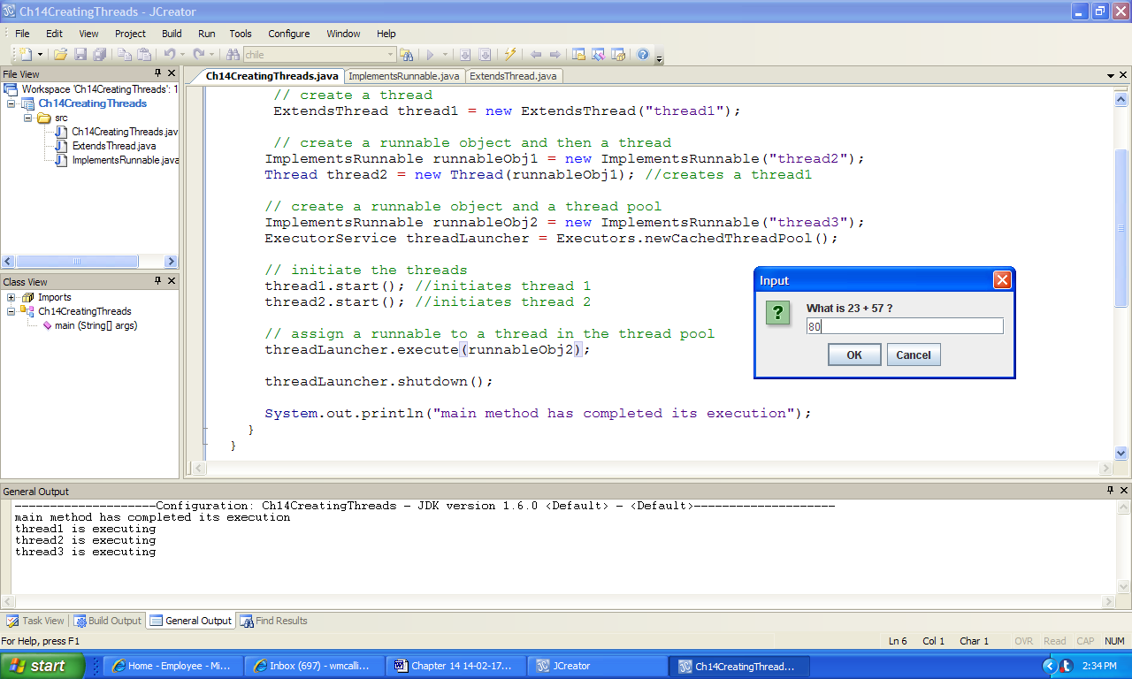

***Console Output:***

main method has completed its execution

thread1 is executing

thread2 is executing

thread3 is executing

Correct 23 + 57 = 80

**Figure 14.5 An input to the application CreatingThreads and outputs generated by it.**